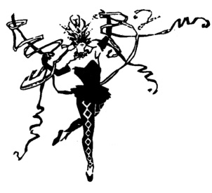
Lisa Allen’s Dance Works
10880 Colerain Road
Saint Marys, GA 31558
(912) 673-9161
www.ladanceworks.net
Registration and Waiver Form
Student Last Name: | Student First Name: |  | Age: |  | DOB:
Student Last Name: | Student First Name: |  | Age: |  | DOB:
Parent Last Name: | Parent First Name: |  | Email Address:
Home Phone: | Cell Phone: |  | Work Phone:
Street Address: |  | City: |  | State: |  | Zip:

Driver’s License Number and State: We must have to accept checks. ____________________________________________________

If an emergency should occur, please list (2) people with whom we may communicate:

Name: ______________________________ __________ Phone: _________________________ Relationship: ___ ___________

Name: _______ _____________ ___________________ Phone: _________________________ Relationship: __ ____________

*Medical conditions Instructor should be aware of: ___________________________________ __________________________________

Previous Training: (check all that apply)
Pointe: __________Lyrical: __________Musical Theatre: ___________Ballet: __________Modern: __________Hip Hop: ___________

Cheer: __________Jazz: __________Tap: ___________ Other: ____________________________ Years: ____________________

Class or Classes you wish to register for:

Name of class: ______________________________________ Day: _____________ Time: _______________
Name of class: ______________________________________ Day: _____________ Time: _______________
Name of class: ______________________________________ Day: _____________ Time: _______________
Name of class: ______________________________________ Day: _____________ Time: _______________

How did you hear about Lisa Allen’s Dance Works?

___ Word of mouth ___ Flyer ___ TV or Newspaper Ad ___ Internet (WEBSITE/FACEBOOK) ___ Drive By
___ Friend Name of friend: ______________________Other: ____________________ Referred by: _____________________________________

I fully understand & agree to abide by Lisa Allen’s Dance Woks Inc. Policies and Guidelines (under separate cover).

Signature of parent or legal guardian is required:

Print Full Name of Parent/ Legal Guardian: _______________________ ____________________________

Signature of Parent/Legal Guardian: ___________________________________________________________ Date: _________________

Dancer sign here if 18 years of age or older:

Print Full Name: ___________________ ______________________________________

Signature: ______________________________________________________ Date: ____________________

