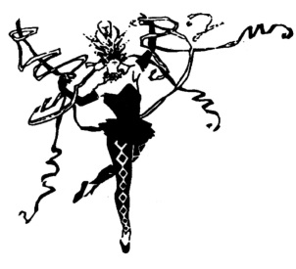
Lisa Allen’s Dance Works
10880 Colerain Road
Saint Marys, GA 31558
(912) 673-9161
www.ladanceworks.net
Adult Registration Form
Last Name: | First Name: |  | Email Address:
Home Phone: | Cell Phone: |  | Work Phone:
Street Address: |  | City: |  | State: | Zip:

Driver’s License Number and State: We must have to accept checks. ____________________________________________________
If an emergency should occur, please list (2) people with whom we may communicate:
Name: ______________________________ __________ Phone: _________________________ Relationship: ___ ___________

Name: _______ _____________ ___________________ Phone: _________________________ Relationship: __ ____________

*Medical conditions Instructor should be aware of: ___________________________________ __________________________________
Previous Training: (check all that apply)
Pointe: __________Lyrical: __________Musical Theatre: ___________Ballet: __________ Modern: __________Hip Hop: ___________

Cheer: __________Jazz: __________Tap: ___________Aerial_______ Other: ____________________________ Years: ____________________
Classes of interest:
Name of class: ______________________________________ Day________________ Time________________
Name of class: ______________________________________ Day________________ Time________________
Name of class: ______________________________________ Day________________ Time________________

_______ 1. Studio Fit Cards: This includes up to 8 classes with a 8 week expiration date and are non-refundable.
_______ 2. Accident and/or Injury: By signing this document you have agreed to hold harmless Lisa Allen’s Dance Works Inc. and staff against any and all claims of responsibility and/or liability for any accident, injuries, and/or illness occurring in and/or on the premises. This shall include any performances or classes scheduled at other facilities as deemed necessary throughout the Dance Year by Lisa Allen, the Director.
_______ 3. Visual Images: We reserve the right to use any photos or audiovisual images associated with Lisa Allen’s Dance Works, Inc. without your prior consent.
_______ 4. Disclaimer: Studio name, logo, photos, audio images, choreography cannot be used without prior written consent of the proprietress and president of Lisa Allen’s Dance Works, Inc.

Print Full Name: ___________________ ______________________________________

Signature: ______________________________________________________ Date: ____________________

Date: | Date Card Expires: | Amount Paid: | Payment

